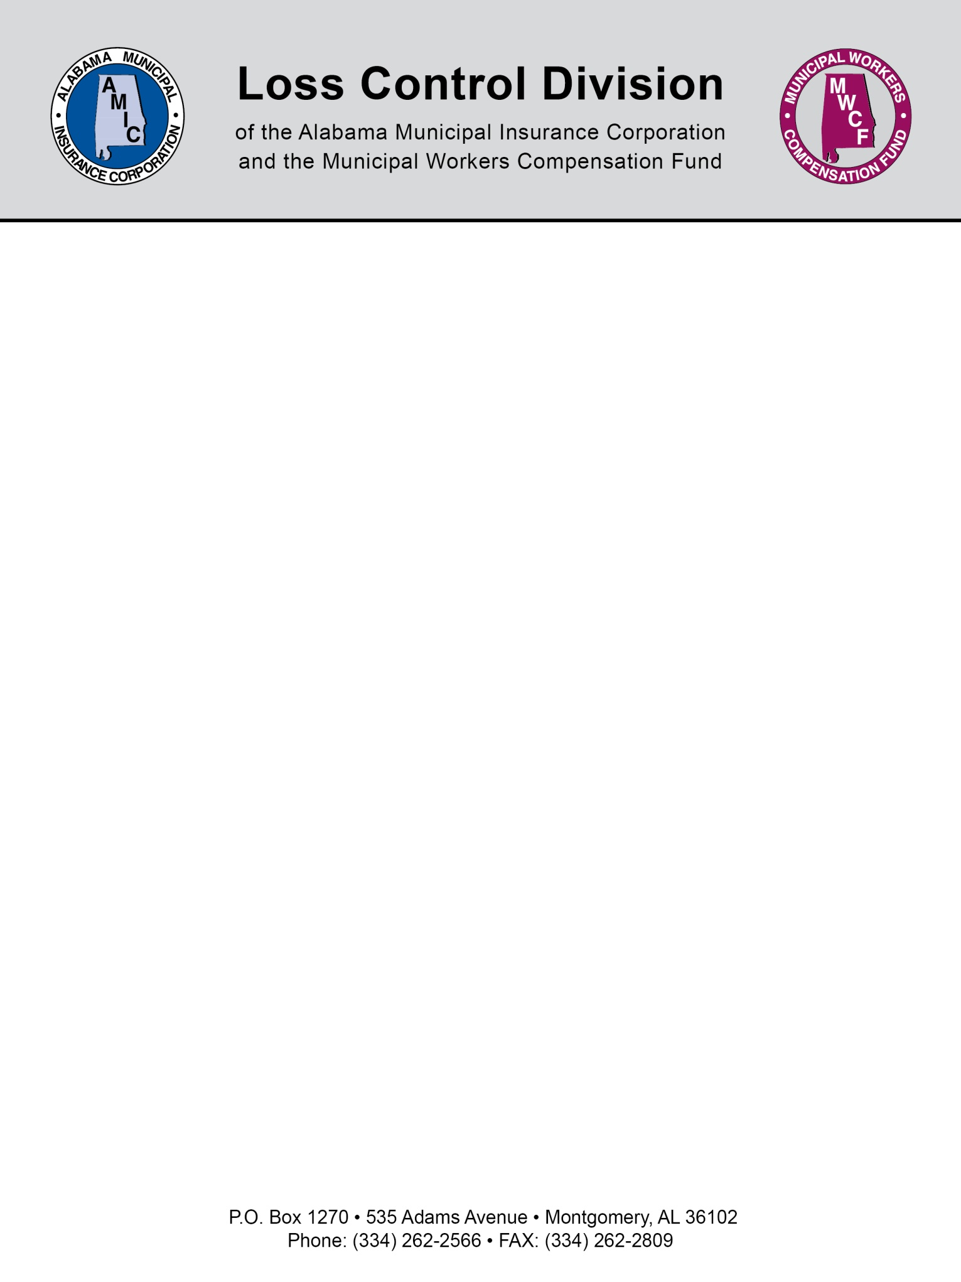

Sample City Motor Vehicle Operations Policy

Purpose: To establish a City Motor Vehicle Policy pertaining to the requirements and responsibilities for operating a City vehicle.

Definition of a City Vehicle: Any vehicle that is owned, leased, rented, or loaned to the City. This includes equipment that does not require a driver’s license but will be operated on a public street.

Drivers License Requirements:

1. Prospective and current employees, whose job duties include the operation of a City vehicle, must be in possession of a valid and current Alabama driver’s license to include the appropriate class of commercial license for the vehicle being operated. Under no circumstances shall a City employee, whose license has been cancelled, revoked, suspended, or expired, operate a vehicle around or about a roadway.

2. During the hiring, promotion, or transfer of a current or prospective City employee, whose duties include the operation of a City vehicle, said employee shall produce a valid and current Alabama driver’s license.

3. An employee, whose job duties include the operation of a City vehicle, shall immediately, within 24 hours, notify his/her department head (or delegated official) of any change in the status of his/her driver’s license or the receipt of any citation for a moving violation in the operation of a motor vehicle whether the citation is on or off the job. Failure to immediately report a driver’s license revocation, suspension, cancellation, or citation, as required by this paragraph, shall result in disciplinary action in adherence with City Rules and Regulations and paragraph 4 of this section.

4. An employee who fails to report a change in the status of his/her driver’s license or the receipt of any citation for a moving violation shall be subject to one or more of the following:

- letter of reprimand, or
- suspension without pay, or
- revocation of driving privileges and transfer/demotion to a job not requiring the ability to drive, or
- termination of employment
Motor Vehicle Record (MVR) Requirements:

1. An applicant for a position with the City, whose job duties include driving a City vehicle, will have his/her current MVR reviewed, prior to being employed, by the hiring authority or so delegated official. If the MVR has greater than eight points in a 24 month period listed for traffic violations or a conviction or pending charge for driving under the influence during that period, that applicant will be disqualified from consideration for the position in question.

2. A current employee whose job description includes the duty to operate a City vehicle will have his/her MVR reviewed at a minimum of every three years. If a current employee has, at any time, an MVR that is found to be greater than eight (8) points according to the points scale for the State of Alabama UTC offense codes, that employee shall be required to attend a defensive driving course at his/her own expense. The accumulation of points is for a 24- month period. The date of reference for points accumulation shall be the date of the conviction. The Risk Management Division shall be responsible for reviewing, around the anniversary date of the employee’s initial hiring or promotion to a position necessitating the driving of a vehicle, the employee’s MVR.

3. The employee who is identified as having an MVR greater than eight (8) points will be given two weeks from the date of notification to present a certificate from a school of defensive driving to the appropriate department head, or the employee’s driving privileges will be suspended until such certification is presented.

4. Any current employee arrested for driving under the influence of alcohol or drugs will be immediately prohibited from operating City vehicles. If the person is ultimately found not guilty of driving under the influence of alcohol or drugs, driving privileges will be returned immediately. If the person is found guilty, driving privileges will be taken away for an additional period not to exceed one (1) year starting with the initial date driving privileges were revoked. If greater than one year has elapsed between the date of arrest and conviction for DUI, the employee’s driving privileges will be revoked for, at least, an additional 90 days from the date of conviction. It is the responsibility of the employee to report such an arrest or conviction to his/her supervisor.

Seat Belt Use

1. Seat belt use is mandatory in all City vehicles. This applies to both the driver and all passengers in seating locations equipped with seat belts.

Procedures for Obtaining Certification to Operate City Vehicles

1. Police and Fire Departments: The Police and Fire Department shall develop their own procedures for certifying employees and applicants to operate City vehicles. These procedures must comply with the driver’s license and MVR requirements outlined in this policy. The Police and Fire Department shall provide the Safety and Training Supervisor with a roster of each graduating academy class. This roster should list new officers and firefighters by name and driver’s license number. Annually, the Police and Fire Department shall provide the Safety and Training Supervisor with a list of authorized drivers.

2. All Other Departments: All new employees who may, as a part of his/her job duties, operate City vehicles or current employees being promoted or transferred into positions that may require operating City vehicles will have their driver’s license and current MVR reviewed by the appropriate department head or designee. The purpose of this review is to ensure compliance entitled, Drivers License Requirements and Motor Vehicle Record (MVR) Requirements of this policy. The MVR and the employee will be brought to the Safety and Training Supervisor who will certify the employee to operate City vehicles and brief the employee on the City Motor Vehicle Operations Policy.

Involvement of the City Attorney’s Office

1. The City Attorney’s office will be notified of any accident that involves personal or bodily injury to a City employee or another party. This notification should be made in writing by the employee’s department head. Further personnel action as to the employee involved in the accident shall be suspended until the City Attorney gives directions with regard to the disposition of the employee and/or accident review/investigation.

2. A representative of the City Attorney’s Office should be present at ALL hearings of the accident review board.

Central Accident Review Board

1. Effective with implementation date of this policy, there shall be created a Central Accident Review Board. The purpose of this board will be to review all motor vehicle accidents that involve City employees.

2. The Risk Manager will serve as the administrator of the Accident Review Board. As administrator, the Risk Manager will be responsible for setting the agenda for the Board, determining the meeting dates and times, and keeping minutes from the Board. All decisions of the Board will be forwarded by the Risk Manager to the affected department head for implementation. The decision is to be implemented by the department unless the employee requests an appeal before the Mayor.

3. The Accident Review Board will consist of five (5) voting members, who shall serve for a term of one year. All five members must be present to effect a recommendation for any discipline of an employee. In the event a Board member is unable to attend, the appointing authority shall be empowered to select an alternate, who shall serve as an alternate for a term of one year. The members will be appointed as follows:

- Representative of the Police Department (appointed by the Chief of Police)

- Representative of the Fire Department (appointed by the Fire Chief)

- Representative of the Sanitation Department (appointed by the Sanitation Director)

- Representative of the Maintenance Department (appointed by the Maintenance Director)

- Representative of the Police Department who has experience, of a supervisory level, in the investigation of accidents (appointed by the Chief of Police).

4. The members of the Accident Review Board will elect a chairperson. That chairperson will conduct the meetings and serve as parliamentarian. All Board meetings will be operated according to an accepted rule of order as determined by the Board.

5. All departments will submit accident reports/incident reports involving their employees to Risk Management for review. Risk Management shall conduct an initial investigation to determine whether the accident was CLEARLY NON-PREVENTABLE. Those accidents that are deemed CLEARLY NON-PREVENTABLE, after investigation by Risk Management, will not need to be reviewed by the Accident Review Board. Risk Management will notify the effected department head of whether the accident is clearly non-preventable or whether the accident is being referred to the Accident Review Board.

6. The employee/driver involved in an accident which is to be reviewed shall be given at least two weeks written notice by the Board of the date when he/she is to appear before the Board. The written notice shall be given by the Risk Management Division. A Risk Management Division representative shall be responsible for serving as the prosecutor. The prosecutorial responsibilities will include calling witnesses and presenting evidence to the Board. The employee/driver shall also have the right to bring witnesses and submit evidence to the board. Employees are not entitled to be represented by an attorney at the Board meeting.

7. The Board review will determine whether an accident was preventable or non-preventable and recommend disciplinary action for implementation by the employee’s department head. The Board will use the following criteria to make these decisions.

- Number of previous preventable accidents while operating a City vehicle.
- Severity of the loss
- Contributing/mitigating circumstances to the accident
- The egregious/wanton nature of the accident
- Consideration of the preventability of the driver’s actions
- The employee’s previous work record

8. Any appeal of the board’s decision will be made directly to the Mayor’s Office within five (5) working days.

9. The appeals process will follow the same as all disciplinary actions to include appeal to the Mayor’s Office and the Personnel Board for suspensions of 6 days or more.

Responsibilities

1. Department heads shall be responsible for:

  - Ensuring that employees are aware of the driver’s license requirement and Motor Vehicle Record (MVR) requirement of this policy.
  - Ensuring that the proper procedures are followed for certifying employees to operate City vehicles.
  - Ensuring employees are aware of and comply with the seat belt usage requirement.

NOTE: This document is not intended to be legal advice. It does not identify all the issues surrounding the particular topic. Public agencies are encouraged to review their procedures with an expert or an attorney who is knowledgeable about the topic. Reliance on this information is at the sole risk of the user.

Revised 11/2013

